Assignment 3 worksheet

MPL CHAPTER 5 programMING PROJECTS

This ASSIGNMENT contains the following activities:

|  |  |
| --- | --- |
| Activity 3.1 | Choosing Your Programming Projects |
| Activity 3.2 | Submitting your Solution |

|  |  |
| --- | --- |
| Activity 3.1 | Choosing your Programming Project |
| Overview | In Activity 3.1, you choose your Programming Project. |

1. Review MyProgrammingLab Chapter 5, “Programming Projects” and choose one out of two projects:
2. A showChar Method (73084)
3. Test Average and Grade (73085)

**Note:**

* These 2 “Programming Projects” descriptions are included at the end of this Doccument (See Appendix).

|  |  |
| --- | --- |
| Activity 3.2 | Submitting Your Solution |
| Overview | In Activity 3.2, you submit your solution. |

1. After writing, compiling and running the programming project of your choice successfully (or partially). Take a screen shot of the Output by pressing Alt+Prt Scr and then paste it here (into your CISC190 - Assignment03_worksheet) file by pressing Ctrl+V.

**<< PASTE THE SCREEN SHOT HERE >>**

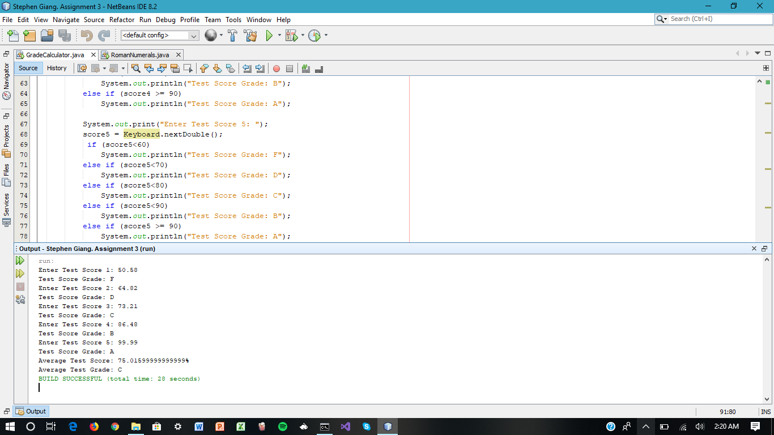

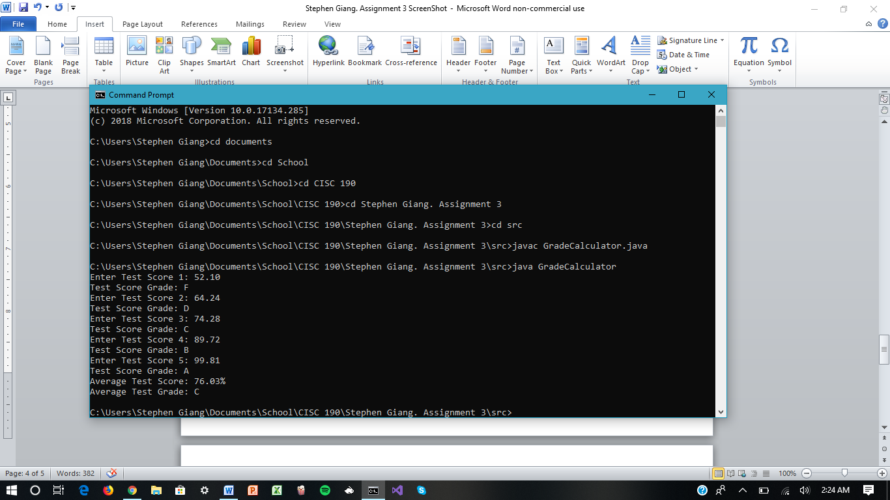

**Note:**

*If you can't Submit the Solution through the MPL's Workbench. Once you have filled in the required information, save the file to your flash drive / hard disk. Then, you can submit it to your instructor through your Blackboard Course for review and grading.*

**Appendix**

1. **A showChar Method (73084)**

Write a method named showChar. The method should accept two arguments: a reference to a String object and an integer. The integer argument is a character position within the

String, with the first character being at position 0. When the method executes, it should

display the character at that character position. The method does not return anything.

Here is an example of a call to the method:

showChar("New York", 2);

In this call, the method will display the character w because it is in position 2. Demonstrate the method in a complete program.

1. **Test Average and Grade (73085)**

Write a program that asks the user to enter five test scores. The program should display a

letter grade for each score and the average test score. Write the following methods in the

program:

calcAverage:

This method should accept five test scores as arguments and return the average of the scores.

determineGrade:

This method should accept a test score as an argument and return a letter grade for the score, based on the following grading scale:

Score Letter Grade

90-100 A

80-89 B

70-79 C

60-69 D

Below 60 F